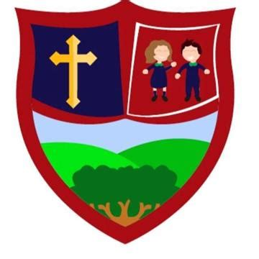
Moneynick Primary School
Prayer Booklet

September 2022
Primary 1
Help your child make the sign of the cross and say:
In the name of the Father, and of the Son, and of the Holy Spirit. Amen
Irish
In ainm an Athar, agus a Mhic, agus an Spioraid Naomh. Amen
Morning Prayer
Father in heaven you love me, you’re with me night and day, I want to love you always, in all I do and say. I try to please you Father, bless me through this day. Amen

Glory Be
Glory be to the Father,
And to the Son,
And to the Holy Spirit,
As it was in the beginning,
And is now and ever shall be,
World without end.
Amen
Night Prayer
God, our Father, I come to say, thank you for your love today, thank you for my family, and all the friends you give to me. Guard me in the dark at night and in the morning send your light. Amen

Grace After Meals
Thank you, God, for the food we have eaten,
Thank you, God, for all our friends,
Thank you, God, for everything.
Thank you, God.
Amen
Grace Before Meals
Bless us, O God, as we sit together,
Bless the food we eat today,
Bless the hands that made the food,
Bless us, O God.
Amen

Prayer to our Guardian Angel
O Angel of God,
my Guardian dear,
To whom God’s love,
commits me here.
Ever this day be at my side,
to light to guard,
to rule and guide.
Amen

School Prayer
May all I say and do,
May all I do and say,
Show your love, Lord Jesus,
Every moment of every day.
Amen

Hail Mary (Sé do bheatha, a Mhuire)
Sé do bheatha, a Mhuire,
atá lán de ghrásta,
Tá an Tiarna leat.
Is beannaithe thú idir mná
agus is beannaithe toradh do bhroinne, Íosa.
A Naomh-Mhuire, a Mháthair Dé,
Guigh orainn na peacaigh, Anois
agus ar uair ár mbáis.
Amen
Amen.

Hail Mary
Hail Mary, full of grace, the Lord is with thee.
Blessed art thou among women, and blessed is the fruit of thy womb, Jesus.
Holy Mary, mother of God, pray for us sinners now, and at the hour of our death.
Amen

Primary 2
Our Father
Our Father, who art in heaven, hallowed be thy name;
Thy kingdom come, thy will be done, on earth as it is in heaven.
Give us this day our daily bread, and forgive us our trespasses, as we forgive those who trespass against us; and lead us not into temptation, but deliver us from evil.
Amen

Journey Prayer
Arise with me in the morning,
Travel with me through the day,
Welcome me on arrival.
God, be with me all the way.
Amen

Primary 3
Prayer for Forgiveness
O my God, help me to remember the times when I didn’t live as Jesus asked me to.
Help me to be sorry and to try again.
Amen

Prayer after Forgiveness
O my God, thank you for forgiving me.
Help me to love others.
Help me to live as Jesus asked me to.
Amen

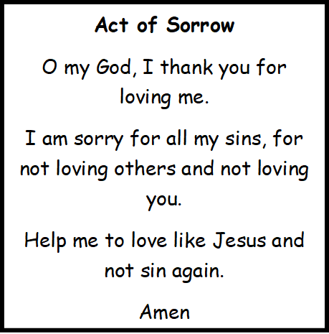
The Confiteor
I confess to almighty God
and to you, my brothers and sisters,
that I have greatly sinned
in my thoughts and in my words,
in what I have done
and in what I have failed to do,
[All strike their breast thrice]
through my fault, through my fault,
through my most grievous fault;
therefore, I ask blessed Mary ever-Virgin,
all the Angels and Saints,
and you, my brothers and sisters,
to pray for me to the Lord our God.
Amen.

Primary 4
Prayer before Communion
Lord Jesus, come to me.
Lord Jesus, give me your love.
Lord Jesus, come to me and give me yourself.
Lord Jesus, friend of children, come to me.
Lord Jesus, you are my Lord and my God.
Praise to you Lord Jesus Christ.
Amen

Prayer after Communion
Lord Jesus, I love and adore you.
You’re a special friend to me.
Welcome, Lord Jesus, O welcome, thank you for coming to me.
Thank you, Lord Jesus. O thank you, for giving yourself to me. Make me strong to show your love Wherever I may be.
Be near me, Lord Jesus, I ask you to stay.
Close by me forever and love me, I pray.
Bless all of us children in your loving care and bring us to heaven to live with you there.
I’m ready now, Lord Jesus to show how much I care.
I’m ready now to give your love at home and everywhere.
Amen

Primary 5
The Angelus
The angel of the Lord declared unto Mary…
And she conceived of the Holy Spirit.
Hail Mary…
Behold the handmaid of the Lord…
Be it done unto me according to thy word.
Hail Mary…
And the Word was made flesh…
And dwelt among us.
Hail Mary…
Pray for us, O holy Mother of God…
That we may be made worthy of the promises of Christ.
Lord,
Fill our hearts with your love, and as you revealed to us by an angel the coming of your Son as man, so lead us through his suffering and death to the glory of his resurrection, for he lives and reigns with you and the Holy Spirit, one God for ever and ever.
Amen

Saint Patrick’s Breastplate
Christ be with me,
Christ be beside me,
Christ be before me,
Christ be behind me,
Christ be at my right hand,
Christ be at my left hand,
Christ be with me wherever I go,
Christ be my friend, for ever and ever.
Amen

Primary 6
Prayers to the Holy Spirit
Holy Spirit, I want to do what is right. Help me.
Holy Spirit, I want to live like Jesus. Guide me.
Holy Spirit, I want to pray like Jesus. Teach me.

Come, Holy Spirit, fill the hearts of your faithful.
Enkindle in us the fire of your love.
Send forth your Spirit and we shall be created,
And you shall renew the face of the earth.

O, God, who has taught the hearts of the faithful
By the light of the Holy Spirit, Grant us in the same Spirit to be truly wise
And ever to rejoice in his consolation, through Christ our Lord.
Amen
The Memorare
Remember, O most gracious Virgin Mary, that never was it known that anyone who fled to your protection, implored your help or sought your intercession was left unaided.
Inspired with this confidence, I fly unto you,
O Virgin of virgins my Mother.
To you do I come. Before you I stand, sinful and sorrowful.
O Mother of the Word Incarnate, despise not my petitions, but in your mercy hear and answer me.
Amen

Primary 7
Apostles’ Creed
I believe in God, the Father almighty,
Creator of heaven and earth, and in Jesus Christ, his only Son, our Lord, who was conceived by the Holy Spirit, born of the Virgin Mary, suffered under Pontius Pilate, was crucified, died, and was buried; he descended into hell; on the third day he rose again from the dead; he ascended into heaven, and is seated at the right hand of God the Father almighty, from there he will come to judge the living and the dead.
I believe in the Holy Spirit,
the holy catholic Church,
the communion of saints,
the forgiveness of sins,
the resurrection of the body,
and life everlasting.
Amen

Duneane Parish Prayer
God bless our Parish of
Duneane
Bless our families and friends
May our homes, schools and workplaces
Be places of peace and harmony
May we use our talents each day
To serve you faithfully
And to care for each other
With tenderness, generosity and joy.
We thank you for the beauty
Of the earth around us
And pray for our protection from all harm.
Amen

Rosary
The Joyful Mysteries:
(Said on Mondays and Saturdays, the Sundays of Advent,
and Sundays from Epiphany until Lent)
1. The Annunciation
2. The Visitation
3. The Nativity
4. The Presentation
5. Finding in the Temple
The Luminous Mysteries (Mysteries of Light):-(Thursday)
1. The Baptism of the Lord
2. The Wedding of Cana
3. The Proclamation of the Kingdom
4. The Transfiguration
5. The Institution of the Eucharist
The Sorrowful Mysteries:-(Tuesdays, Friday)

1. Agony in the Garden
2. Scourging at the Pillar
3. Crowning with Thorns
4. Carrying the Cross
5. The Crucifixion
The Glorious Mysteries:-(Wednesdays)
1. The Resurrection
2. The Ascension
3. The Descent of the Holy Spirit
4. The Assumption
5. The Coronation of Blessed Virgin Mary
The Hail Holy Queen (said after the completion of the five mysteries)
Hail! Holy Queen, Mother of Mercy, our life, our sweetness, and our Hope. To thee do we cry, poor banished children of Eve. To thee do we send up our sighs, mourning and weeping in this valley of tears. Turn then, O most gracious advocate, thine eyes of mercy toward us; and after this our exile, show unto us the blessed fruit of thy womb, Jesus. O clement! O loving! O sweet Virgin Mary!
Pray for us, O Holy Mother of God. That we may be made worthy of the promises of Christ.
Let Us Pray
O God, whose only begotten Son,
By His life, death and resurrection has purchased for us
The rewards of eternal life, grant, we beseech Thee, that
meditating upon these mysteries in the most Holy Rosary of
The Blessed Virgin Mary, we may imitate what they contain and
obtain what they promise: through the same Christ, our Lord.
Amen.
For the intentions of the Holy Father, recite one "Our Father," one "Hail Mary," and a "Glory Be."
In the name of The Father, and of The Son and of The Holy Ghost. Amen.

