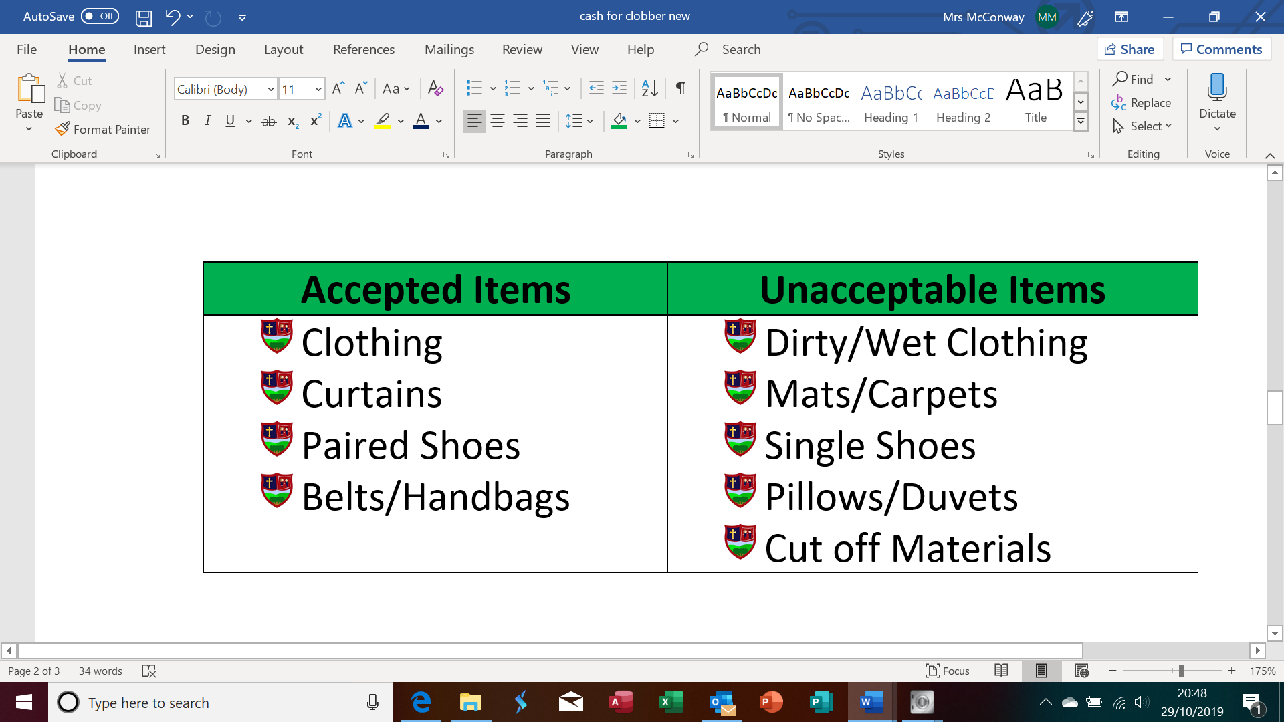

**Thank you for supporting**

**Moneynick Primary School**

**You can place items for recycling in a black bag and send them for recycling to Moneynick Primary School**

**on or before Friday, 29th November 2019.**

**Getting ready for Christmas and having a clear out?**

Cash for Clobber Fundraiser

Moneynick Primary School