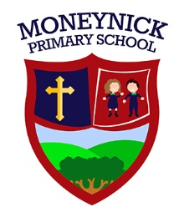
104 Moneynick Road, Randalstown, BT41 3HS
MONEYNICK PRIMARY SCHOOL
Telephone: 028 79650331
Principal: Mrs F McConway

Tuesday 9th June 2020
Dear Parents,
We have asked you to keep Friday the 12th June at 11a.m. free to celebrate with our Year 7 children. Unfortunately, with things the way they are, we are not able to have our usual leavers’ mass in our school hall. However, we have arranged something else to mark this special time for your children.
We would like to invite you all to join in a ‘drive-in’ celebration so that social distancing rules can be adhered to. Our plan is for you all to meet at Moneynick Service Station at 10.50a.m. with the Year 7 children in their school uniform. There will be one car per family. Kerri Devlin has been asked to make sure all 11 cars are there and leaving sharp at 11a.m., she will lead the way up the Moneynick Road to the school. Please toot your horns and cheer loudly! All staff members will be there ready and waiting, cheering the Year 7s as they arrive. One by one, drive around the side of the school and park on the grass pitch at the back, facing the school. There is plenty of space to ensure that 11 cars can park 2 metres apart. Please STAY IN YOUR CARS with the windows down.
The Year 7 children only will then be invited to leave their cars and directed to stand in a certain place on the pitch (2 metres apart). All other family members must stay in their cars.
There are some treats for the children and Mrs McConway will say a few words. We will then say our final goodbyes and the children will return to their cars. Leave in order, but be careful, the gate can be tight on exit.
We really hope you can all make it and thank you in advance for your co-operation.
These are very specific instructions but please remember these are for the safety of your families.
Yours sincerely,
Eimear Lavery

