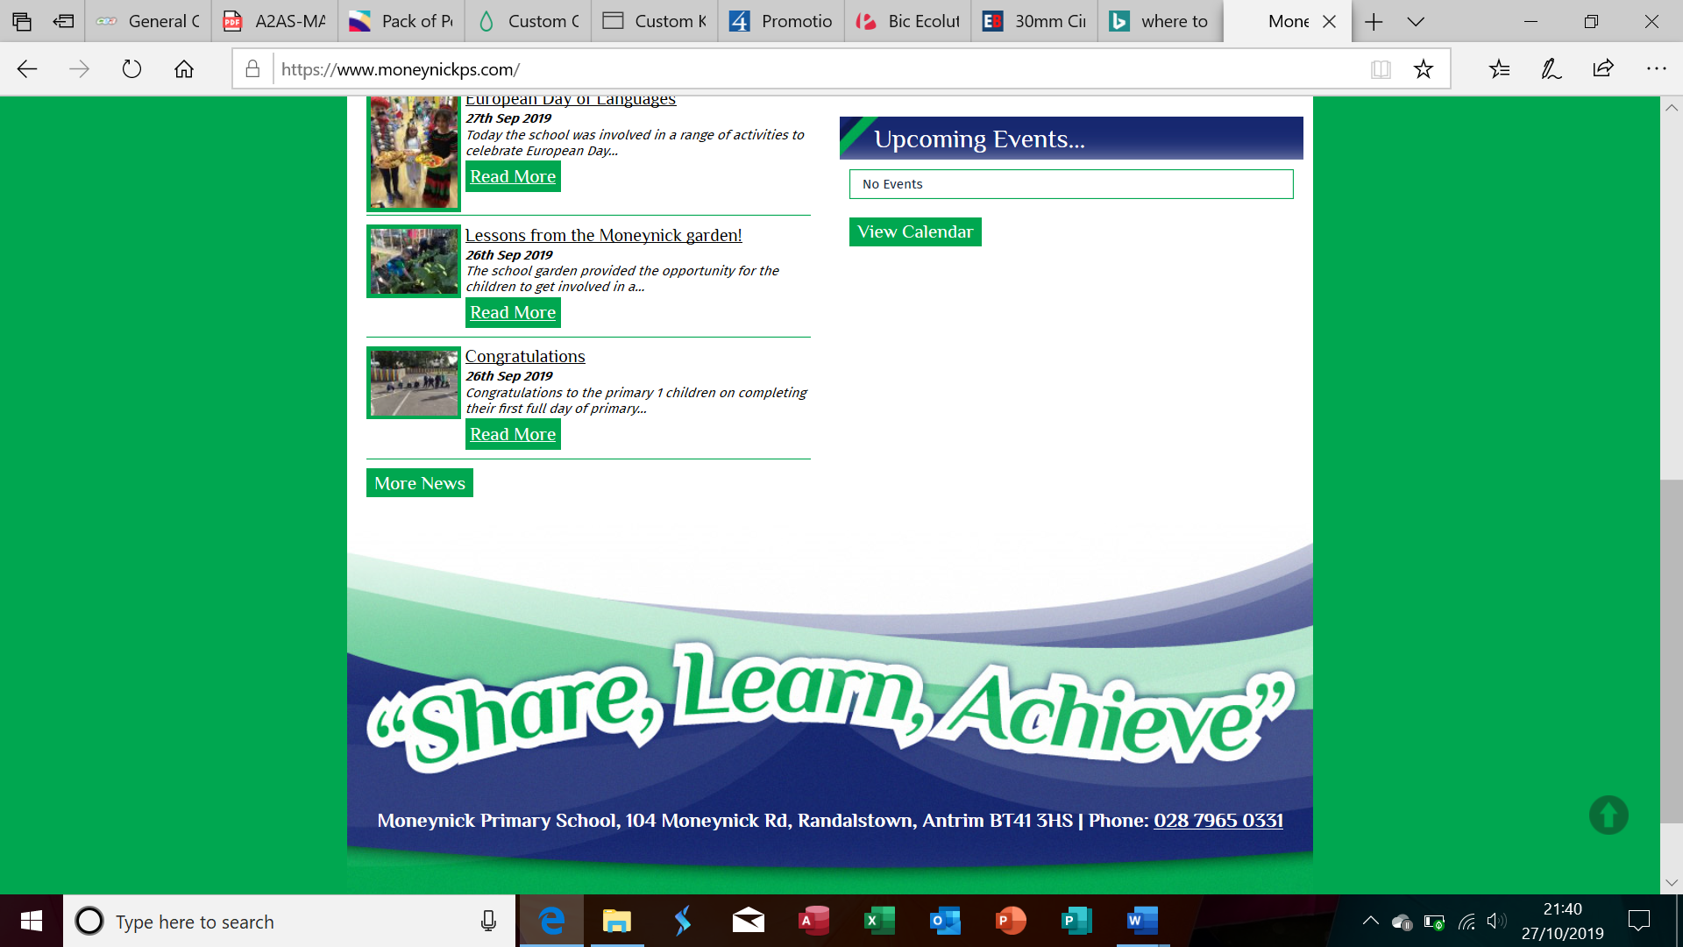

Newsletter

|  |  |
| --- | --- |
| Dates to Remember | |
| **Monday 4 November** | **School Council Campaign** |
| **Tuesday 5 November** | **Bugs and Beasties (P1-4) Swimming (P5-7)** |
| **Wednesday 6 November** | **Falconry Display (All classes)** |
| **Thursday 7 November** | **Outdoor Learning Day** |
| **Friday 8 November** | **School Council Elections** |
| **Monday 11 November** | **Anti-Bullying Week/Judo Demonstration**  **Art Afterschools Club ( 4 Weeks)** |
| **Tuesday 12 November** | **Quiz Club (4 weeks)** |
| **Wednesday 13 November** | **Bully Busters (P6-7)**  **Forest Schools Afterschools Club ( 4 weeks)** |
| **Wednesday 20 November** | **Bully Busters (P6-7)** |
| **Thursday 21 November** | **Visit to Titanic Museum Belfast Primary 6/7** |
| **Friday 22 November** | **Boys’ Indoor Football Tournament - Antrim Forum** |
| **Wednesday 27 November** | **Bully Busters (P4-5)** |
| **Thursday 28 November** | **Girls’ Indoor Football Tournament – Antrim Forum** |
| **Friday 29 November** | **Pupil of the Month Assembly** |
| **Thursday 5 December** | **Open Afternoon**  **Popcorn Party P5-7 3pm-8pm** |
| **Friday 6 December** | **Popcorn Party P1-4 2pm- 7pm** |
| **Thursday 12 December** | **School Concert Performances at 11.30am and 7pm** |

Dear Parents and Pupils,

I am honoured to have been appointed to the position of principal of Moneynick Primary School. In the coming months I am looking forward to getting to know each of the children, school staff and parents. I recognise this is a period of change for everyone, and as we move forward with our school vision, I ask for your continued co-operation and support.

This month we introduce the concept of the School Council in the context of Rights Respecting Schools. This is a democratic forum where our P3- 7 pupils can make their voice heard, impact school decisions and gain experience in serving on a committee. Encourage your child to partake.

The children will celebrate Outdoor Learning Day. This is an opportunity to link Numeracy and Literacy to the outdoor environment. Weather permitting lessons will be taken outside. Please ensure your child has a warm coat, hat and footwear.

With excitement and enthusiasm, I look forward to meeting you all at up-coming events.

Fiona McConway

November 2019

Moneynick Primary School

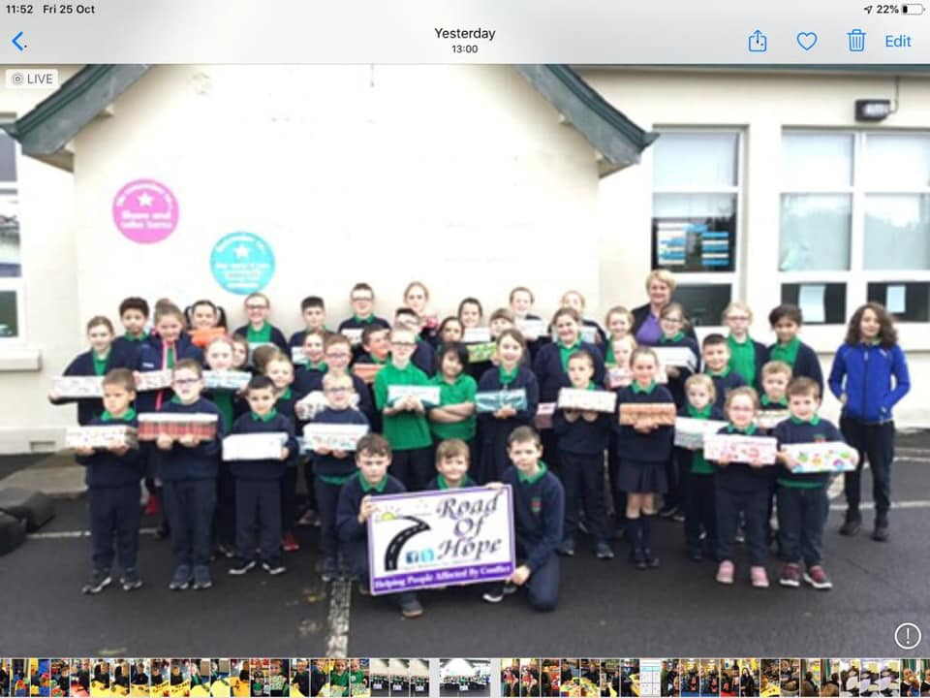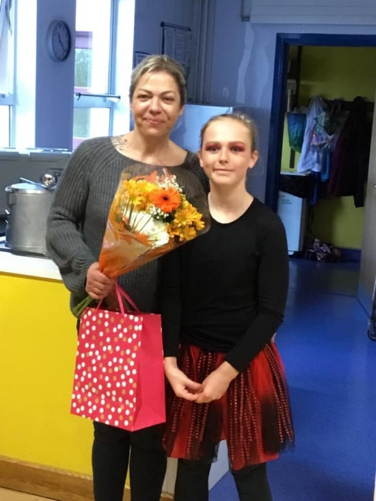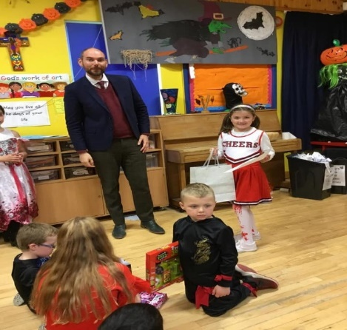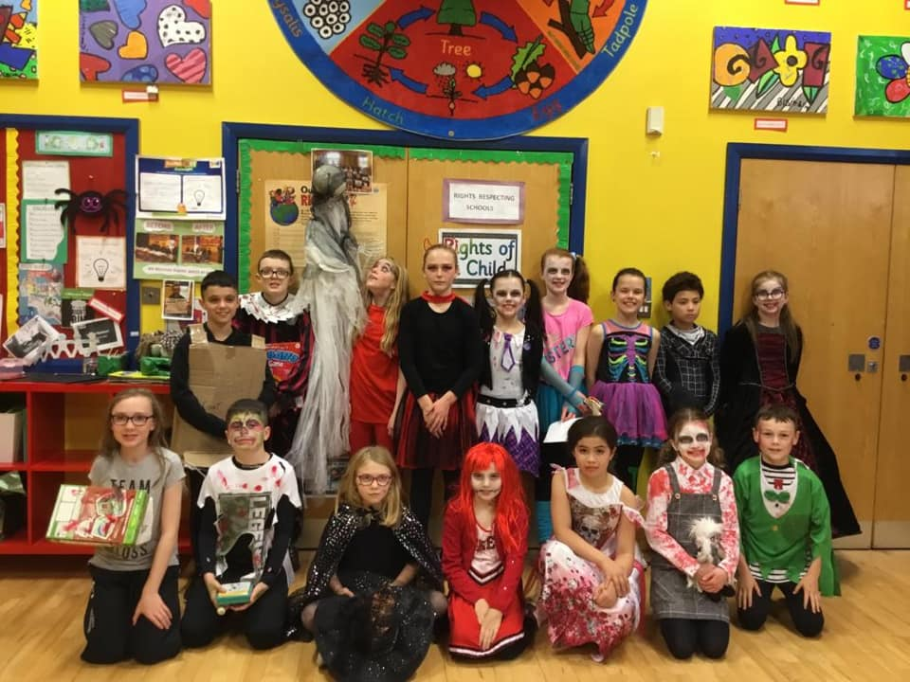

October

Congratulations to the winners of the Apostolic Colouring Competition. We hope you enjoy your prizes.

A big thank you to all our children and their families who raised an amazing £900 for school funds. We appreciate your support!

The school community thanks Mr Morrin for his hard work and commitment. We wish him every success in his future career.

Everyone wishes Laima every success in the future. We thank her for her hard work and dedication.

Pictures

*In*

Our school’s contribution to the ‘Road of Hope’ shoe box collection. A big thank-you to all who participated. What excitement on Christmas Morning when others will receive our gifts!

**Moneynick Primary School, 104 Moneynick Rd, Antrim BT41 3HS | Phone: 028 7965 0331**

Newsletter